

This Back to School Guide has been developed to be a “one stop shop” to help your family get ready for the 2022-2023 school year at Waggoner Road Middle School. We encourage you to read this whole guide before the year begins and keep it handy for reference throughout the year as questions arise.

We are proud to be the Waggoner Road Middle School Wolves and are
excited to welcome your family into our Wolf Pack!

Table of Contents
Raider Check-In & Schedule Pick Up
First Days of School
Teams Night
School Hours
Bus Information
Pick-Up & Drop Off Information
Breakfast & Lunch
Family Communication
Reporting Absences
Required Forms
WRMS Family Calendar
School Supplies
Chromebooks
Google Classroom

Raider Check-In & Schedule Pick Up
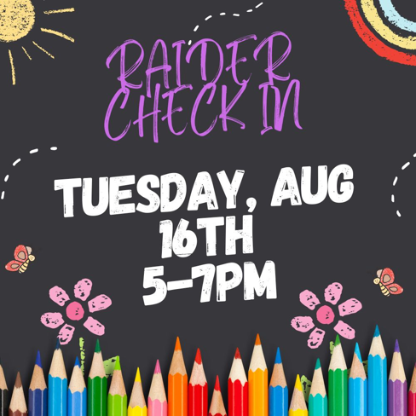

Come pick up your schedule, drop off required forms, pick up your agenda, see your classroom, and meet your teacher on Tuesday, August 16th from 5:00-7:00 p.m.

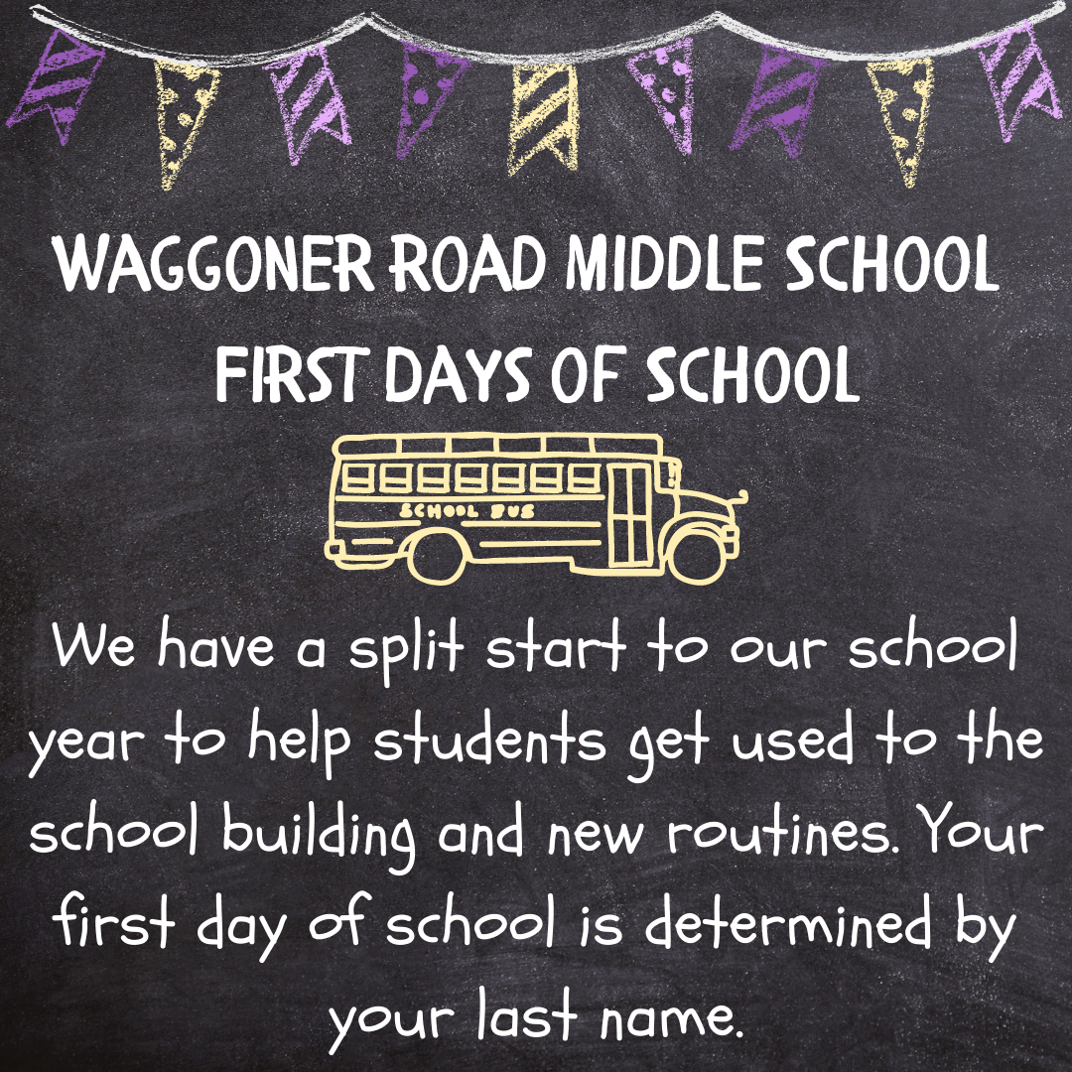
First Days of School
Students with last names A-K:
- Attend on Monday, August 22nd
- Do not on Tuesday, August 23rd
- All students attend on Wednesday, August 24th

Students with last names L-Z:
- Do not attend on Monday, August 22nd
- Attend on Tuesday, August 23rd
- All students attend on Wednesday, August 24th

“Meet the Teams” Night

Join us for a presentation made by your student’s team of teachers on Thursday, August 25th from 5:00-7:00 p.m. This presentation will include what to expect from the year, our expectations for students and our plans for the year.

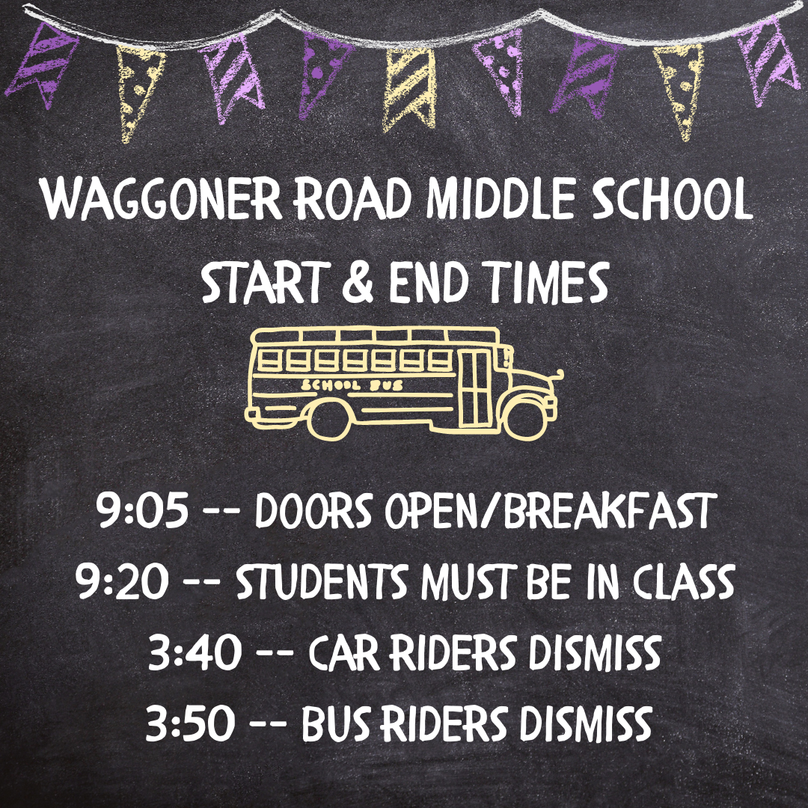
School Hours

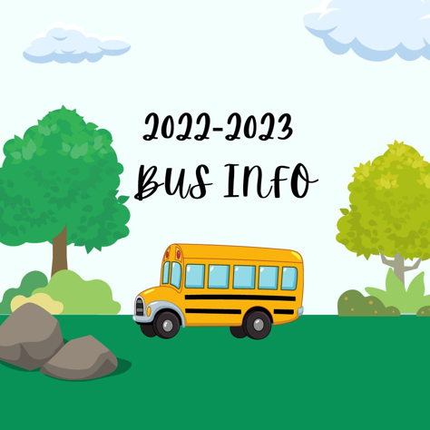
Bus Information

We encourage families to review the Bus Stop Safety and Bus Rules & Regulations (available on the website at https://www.reyn.org/Transportation.aspx) with their children before the first day of school so that we can ensure a safe ride to and from school each day.

Bus route information can be found through our Transportation Department:

Click on the link: elink.reyn.org
- Enter your user name (your student ID number, last 6 digits)
- Enter Password (Default is Student ID number, which is the last 6 digits)
• Follow instructions to change password (only for first time users)
- Click students tab at the top left corner of the page
- Click view my student from the drop down
- Click on student name
- Bus information will appear
- If you have more than one student in the district all of your students’ names will appear and you can click on each student to get their bus stop information.

Pick-Up & Drop-Off
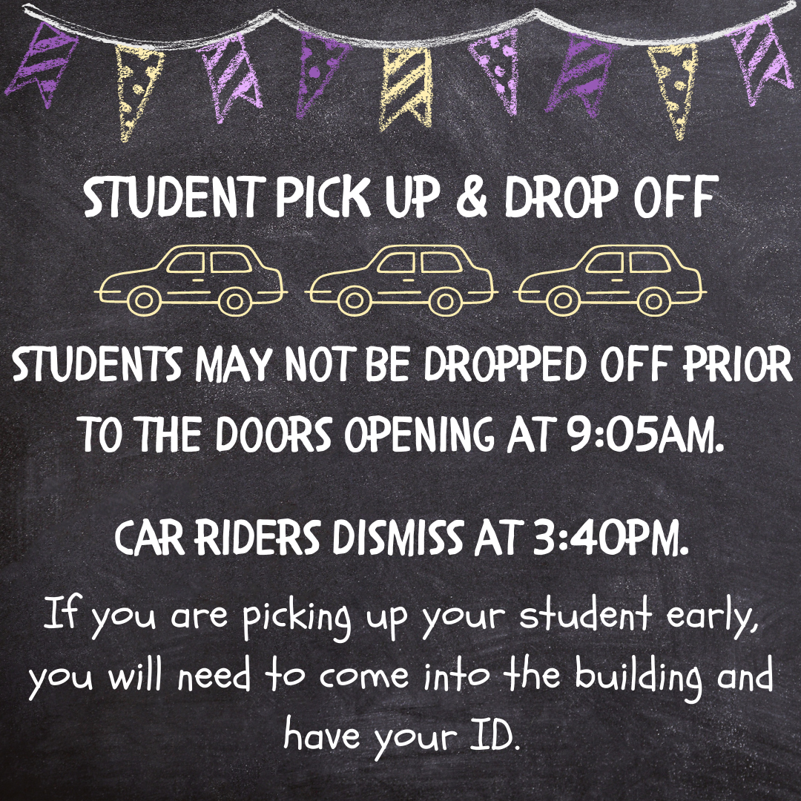
If you choose to transport your student to and/or from school, please follow our 15 mph speed limit at all times and watch for staff directing traffic. We must keep all students safe and we cannot do that without your cooperation.
Drop Off: Students may not be dropped off prior to 9:05 a.m. We do not have supervision available prior to that time. Please pull as far to the end of the curb as possible to help keep traffic moving. After your child exits the car, be careful when re-entering traffic to loop around in front of the Junior High. Cars should not enter the center parking lot.

Pick Up: Car riders dismiss at 3:40 p.m.. Do not park in the parking lot; please pull as far to the end of the curb as possible to keep traffic moving. A staff member will read your student’s name from the card in your windshield or you will tell the staff member your student’s first and last name so that they can radio in for your student to exit the building. After your child is safely in your car, be careful when re-entering traffic to loop around in front of the Junior High. Cars should not enter the center parking lot.

Breakfast & Lunch

WRMS students have access to breakfast and lunch daily thanks to our amazing kitchen team! Additional snacks and drinks may be available for purchase. Money can be added to your student’s account or you can send cash. Students who choose to pack will be provided a safe place to keep their lunch box so that they do not have to carry it with them all day.

Visit the Food Services page of the web site to:


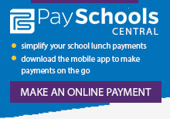



Family Communication
You can expect to receive a weekly newsletter with team and school updates. This will be attached to your student’s homework packet each Friday. Teams will also send an electronic copy.

Teams are in regular contact with families through their newsletters, Class Dojo messaging, email, and telephone. We love two-way dialogue regarding student success so please reach out to your student’s teachers with any questions or concerns throughout the year. If you wish to speak to your child’s teacher on the phone, please email them to set up a time or call the office for assistance (614-501-5600). You will receive a sheet with your team’s contact information at Raider Check-In. Each team will have their own landing page where you can access more information.

We post frequent updates on Facebook and Twitter. Our website is a quick place to find information. If you cannot find what you are looking for, you can give us a call at 614-501-5600.

Reporting Absences
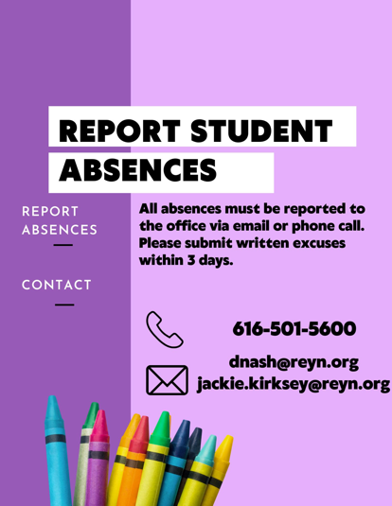

All absences must be reported to the office. If you do not report your child’s absence, we will call your contact number on file.

Email: dnash@reyn.org or jackie.kirksey@reyn.org
Call: 614-501-5600
Include the student’s first and last name along with the reason for the absence.

A written excuse must be provided within 3 days of the absence. If you email regarding the absence, this counts as your written excuse; however, if you have a medical excuse, please provide a copy of it. An emailed photo of the medical excuse works as well.

Required Forms
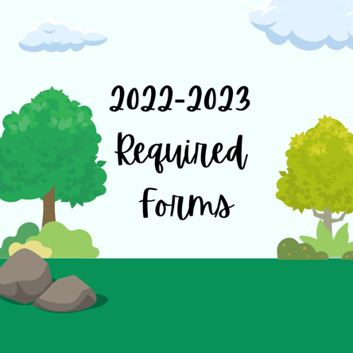
Each student must have the following forms on file for 2022-2023:

Emergency Medical Authorization
Media/Electronic Release
Acceptable Use Form
Parent & Student Handbook Acknowledgement (Handbook)

Families can print these forms to complete prior to coming to Raider Check-In to help the process go faster. There will also be copies available at WRMS during Raider Check-In.

WRMS Family Calendar
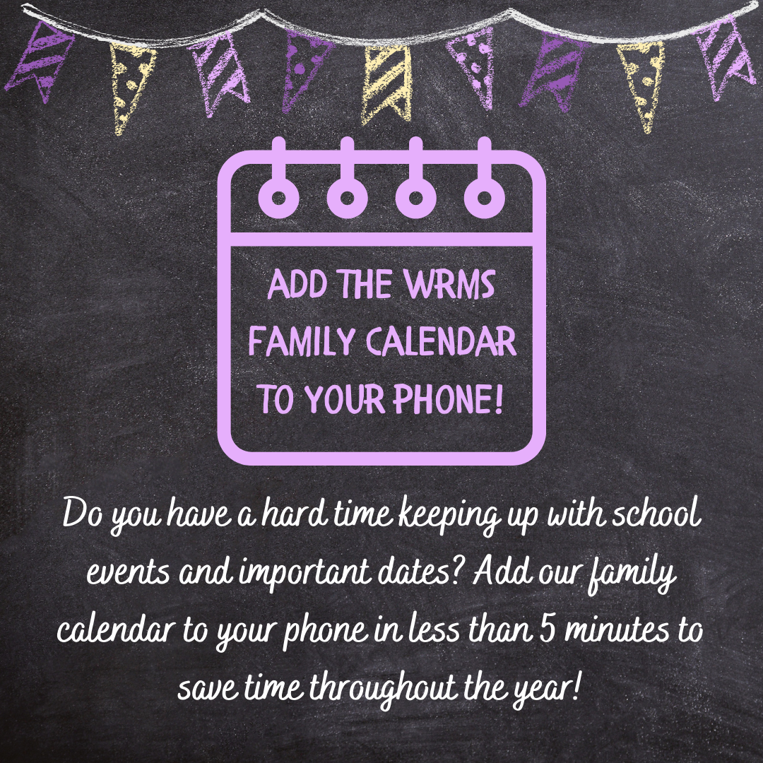

Follow this link to add our WRMS Family Calendar to your phone’s calendar. It should direct you to add it to your preferred calendar service on your phone. The calendar can also be viewed from this link if you don’t want to add it to your phone.


School
Supplies
School Supplies

Our school supply list includes everything your 5th or
6th grader needs for a successful year. Please note that
we do not have lockers so students carry some of their
belongings with them throughout the day. We are mindful of
this in what we ask them to bring to school with them each day so that they do not have heavy backpacks. We highly recommend keeping many of the supplies at home so that they are available to replenish as they get worn out or used up.

Students must have earbuds or headphones for use at school. We do not recommend sending expensive headphones, earbuds, or Air Pods to school.

Students should also bring a water bottle to school with them. We have refill stations available.

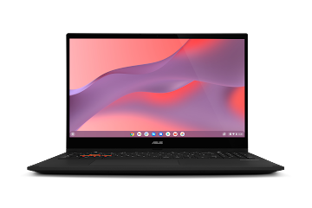
Chromebooks

Each student will have access to a class set of Chromebooks
to be used at school.

Damage or loss of the device and/or charger will result in a bill for repair/replacement. We will go through all expectations for keeping Chromebooks in good working order with students frequently. All students must take pride in the care and use of their device.

Google Classroom

All teachers and students use Google Classroom but grades are in PowerSchool. Google Classroom will be used to manage classwork and resources but students will not be completing all assignments on the computer.

